**Dunning Configuration**

**Defining Dunning procedure categories**

Step 1: Use the below Navigation

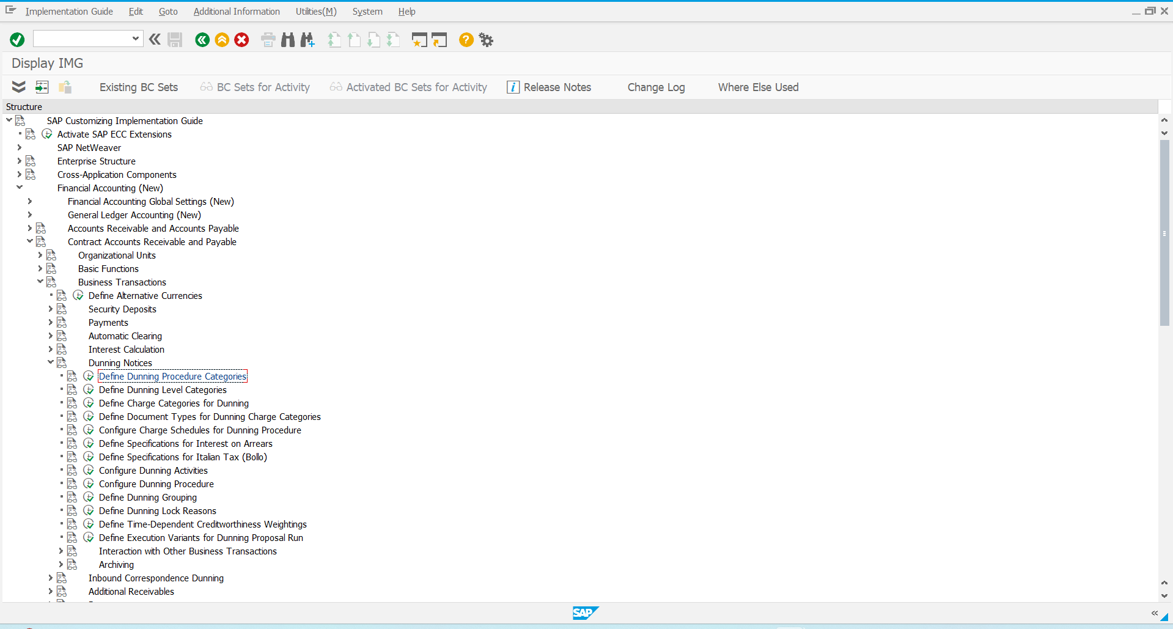

Step 2: Select New entries

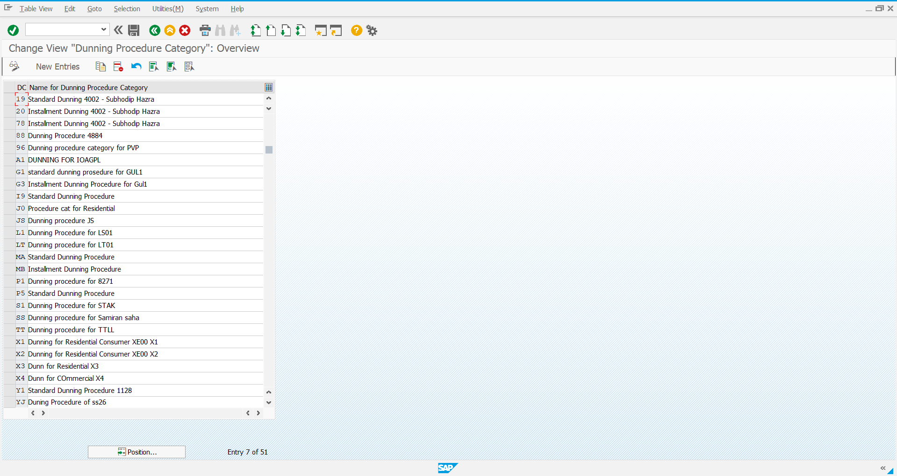

Step 3: Define the dunning procedure and save it

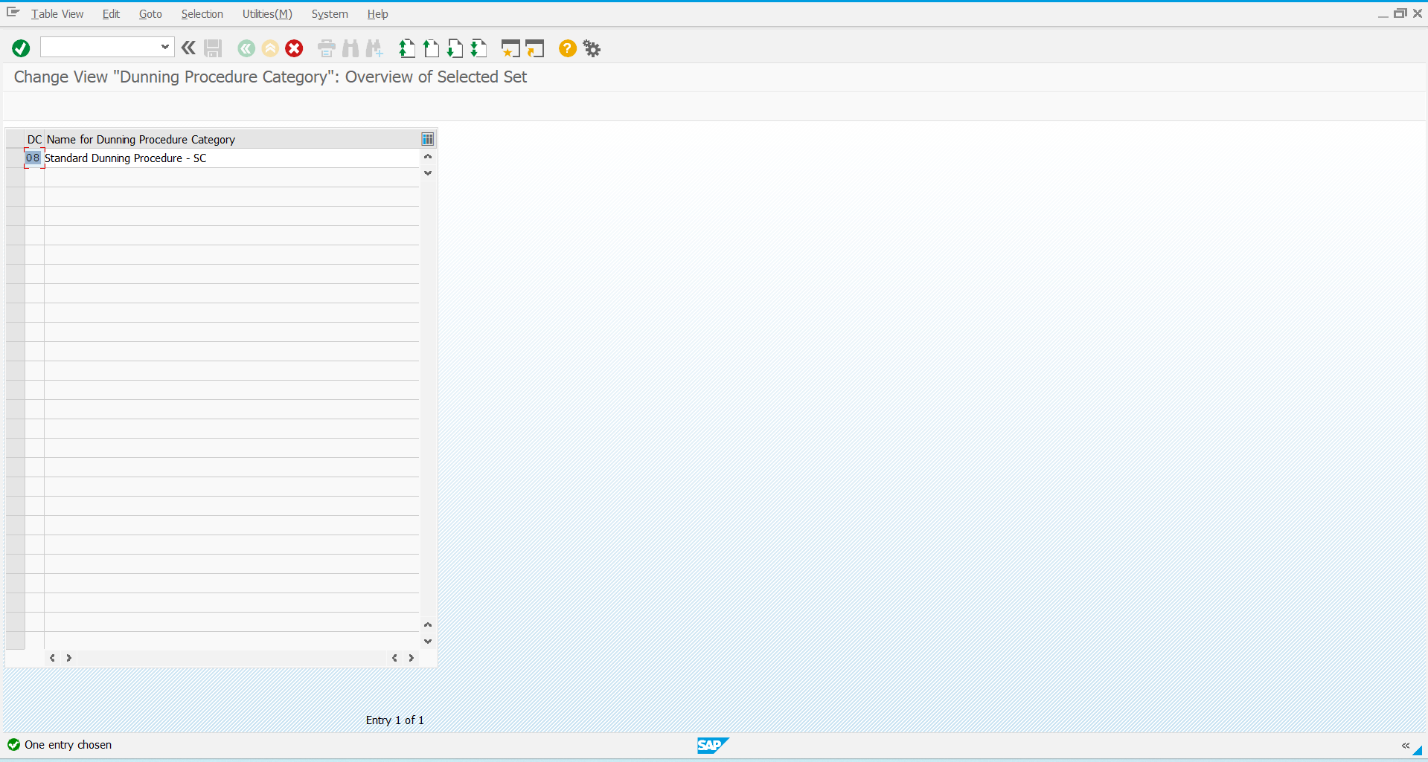

Step 4: New Dunning Category is now available with **key: 08**

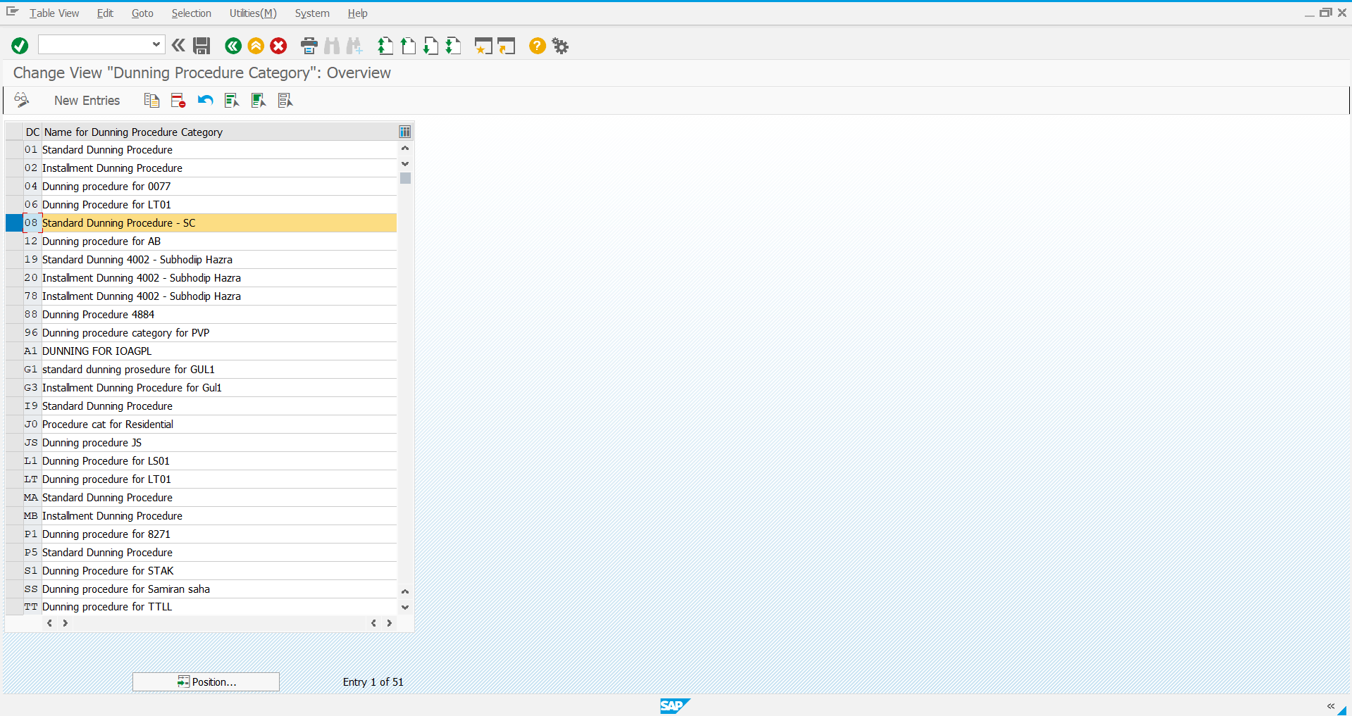

**Define Dunning Level Categories:**

Step 1: Use the below Navigation

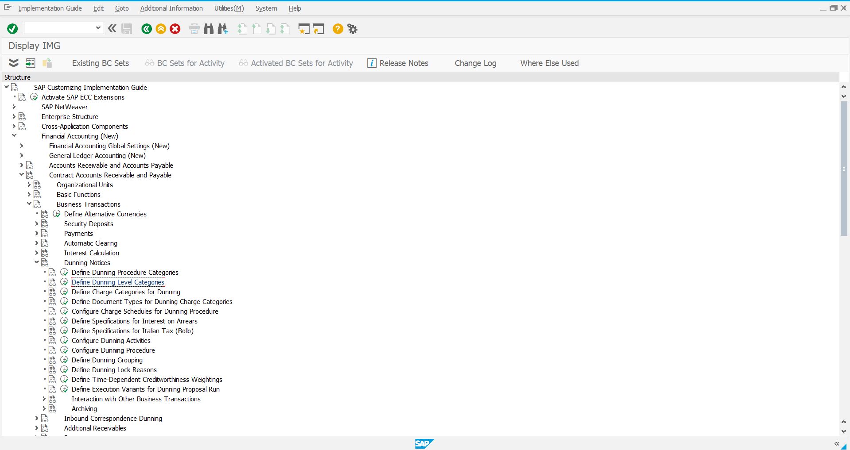

Step 2: Select new entries

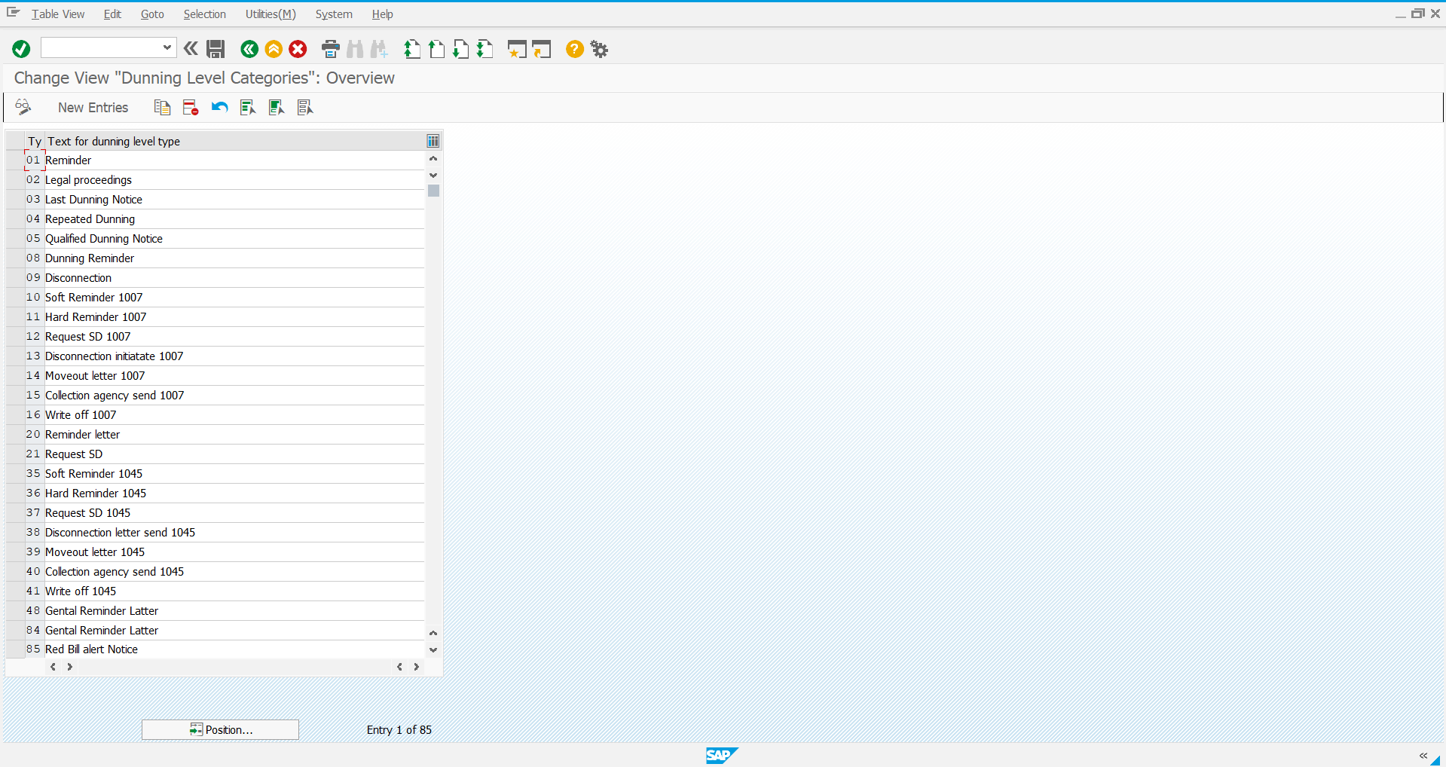

Step 3: Define the new Dunning level and save it

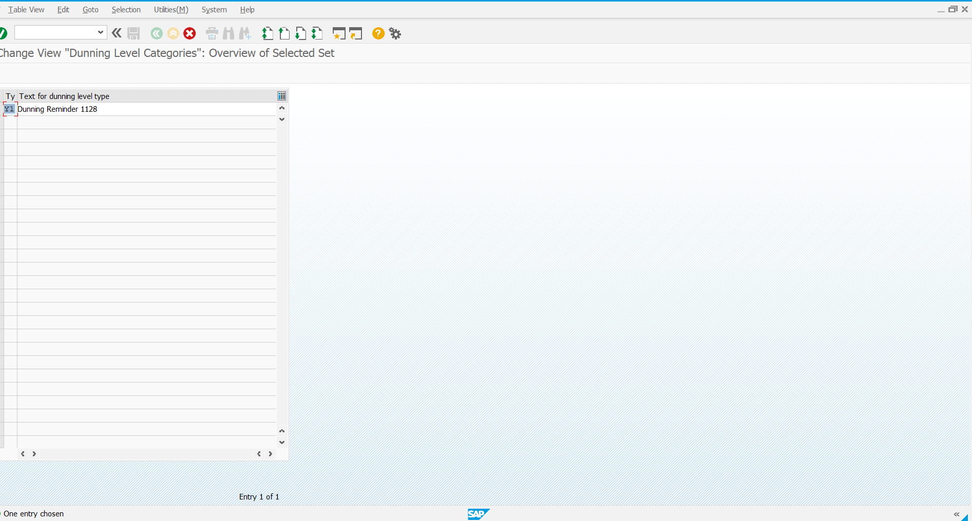

Step 4: New Dunning level available with **key: Y1**

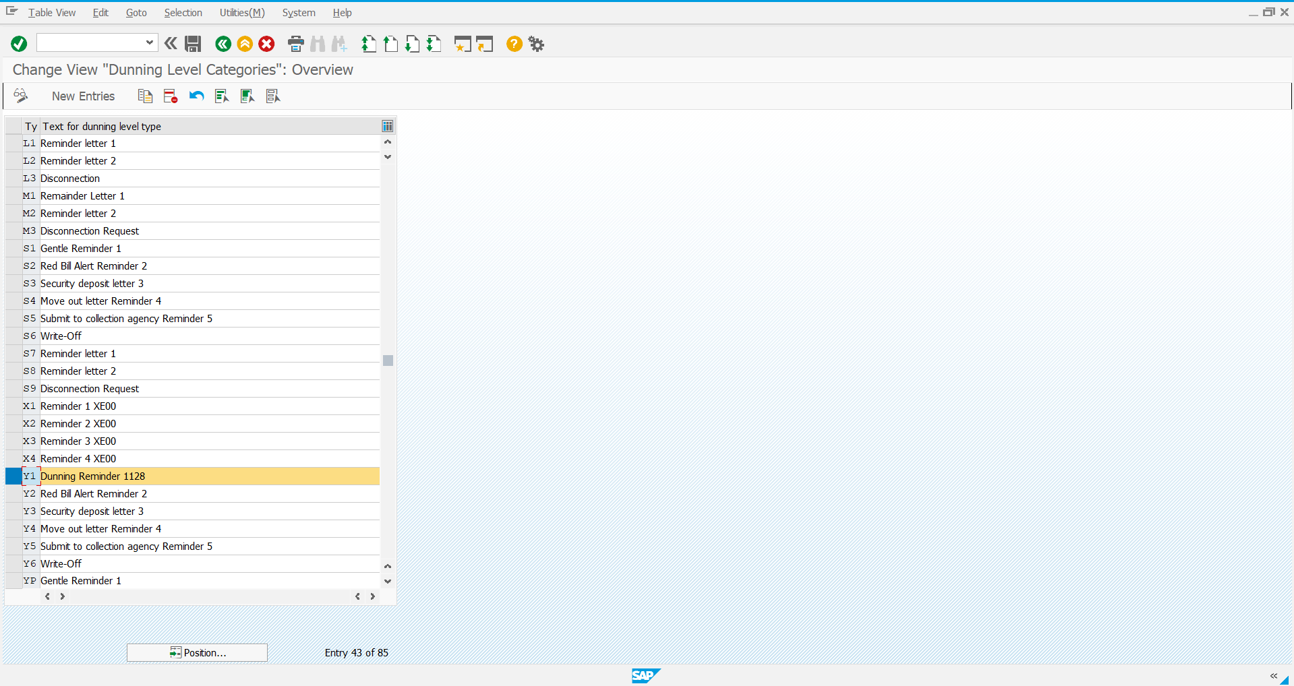

**Define Charge Categories for dunning**

Step 1: Navigate using the below path

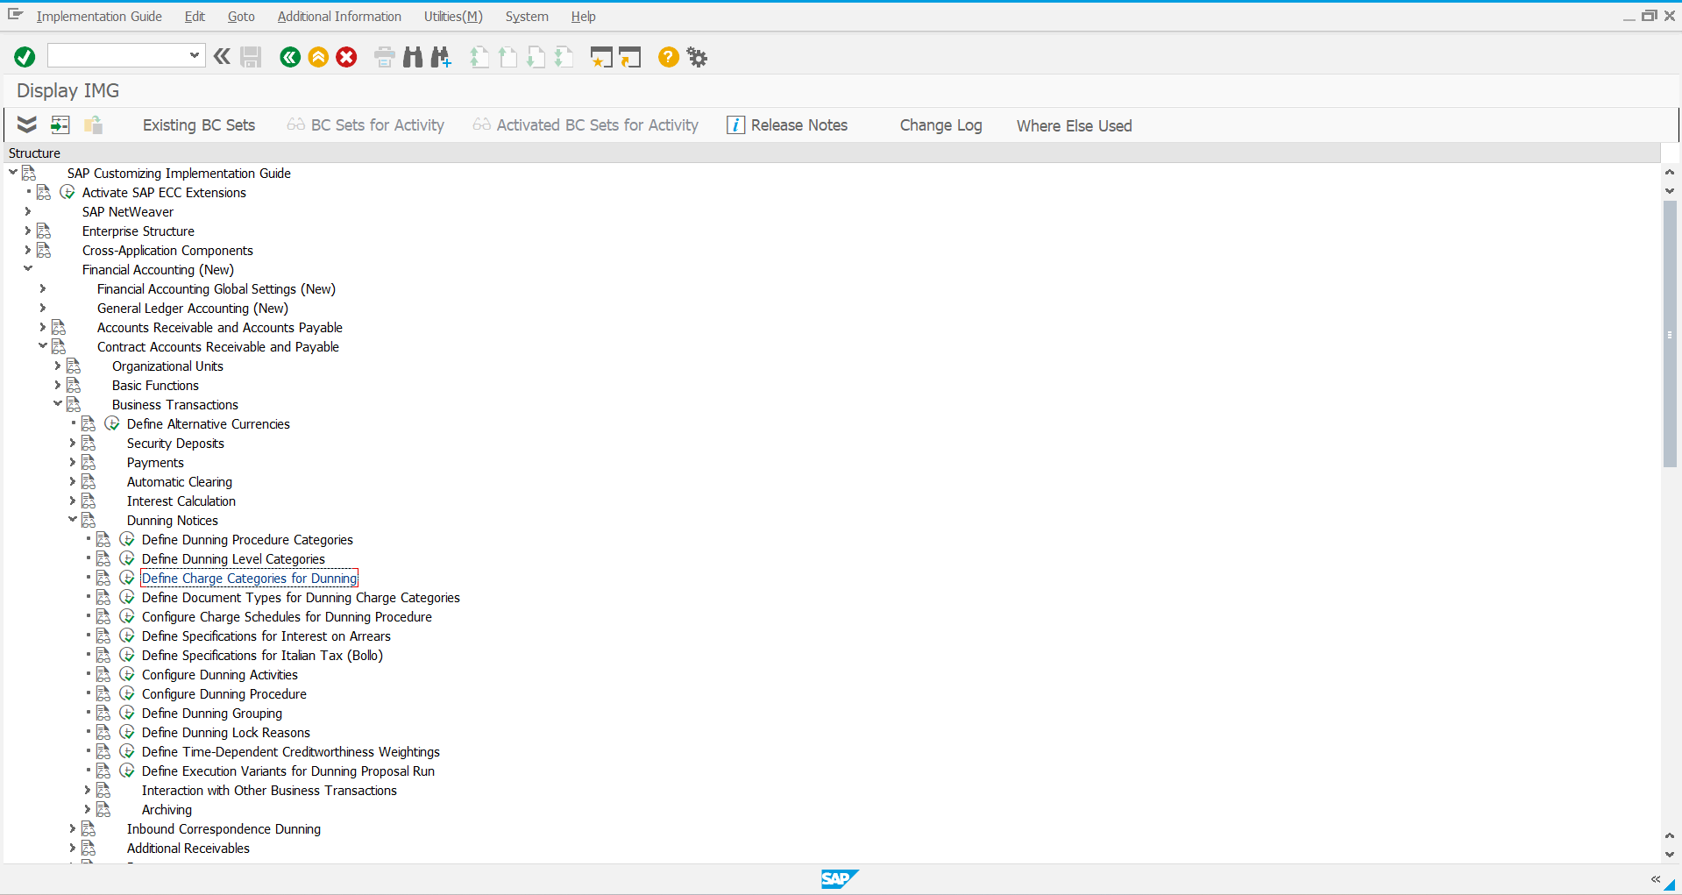

Step 2: Select New entries

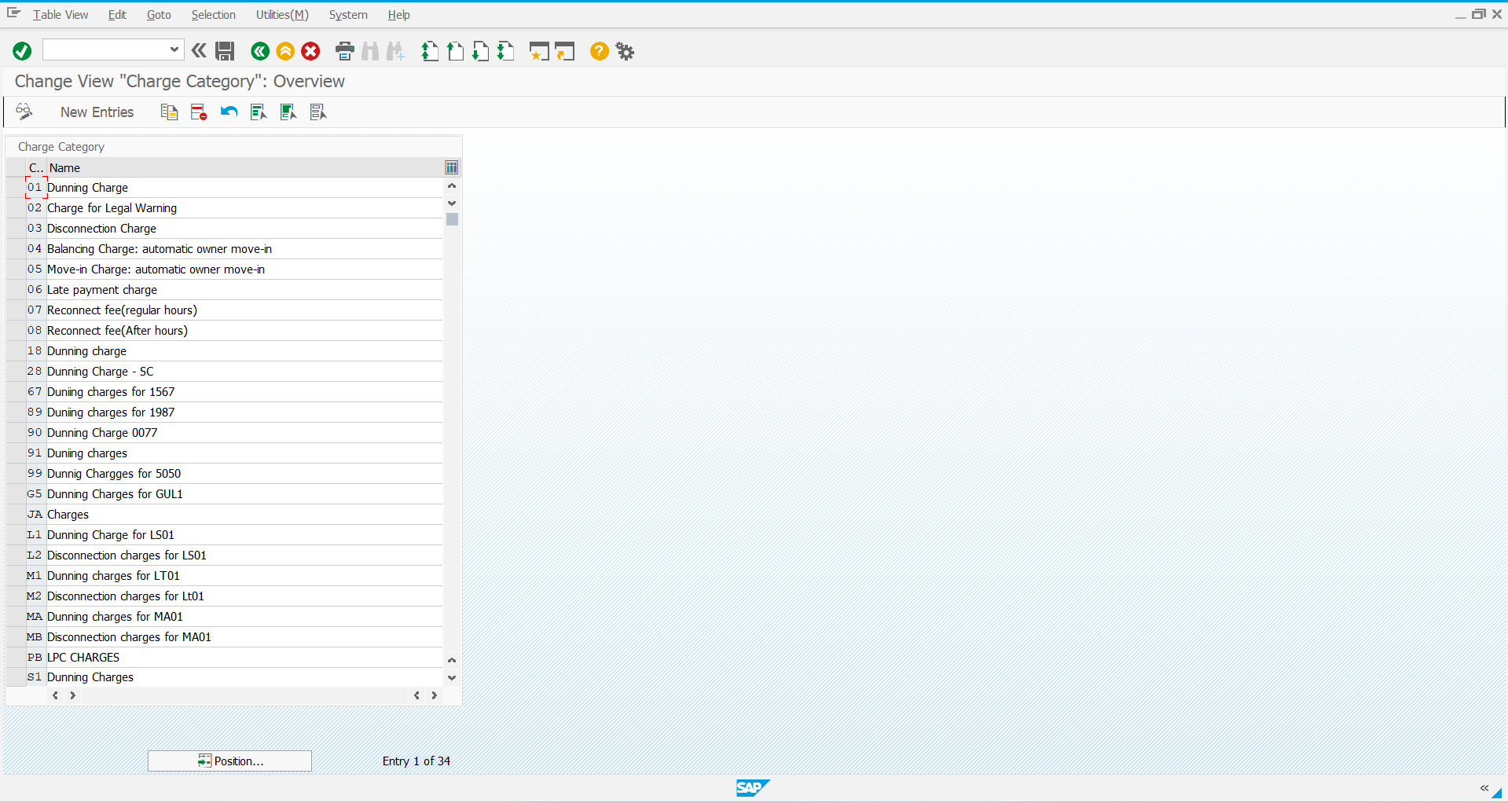

Step 3: Define the new Dunning charge category and save it

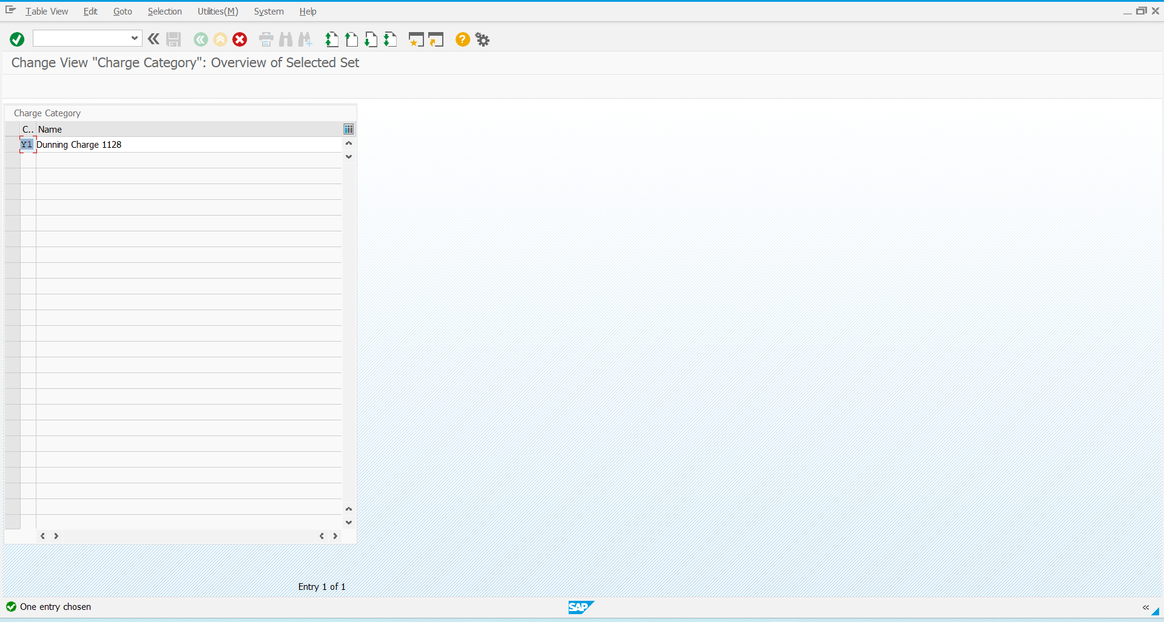

Step 4: New Dunning charge category Is now available with **key: Y1**

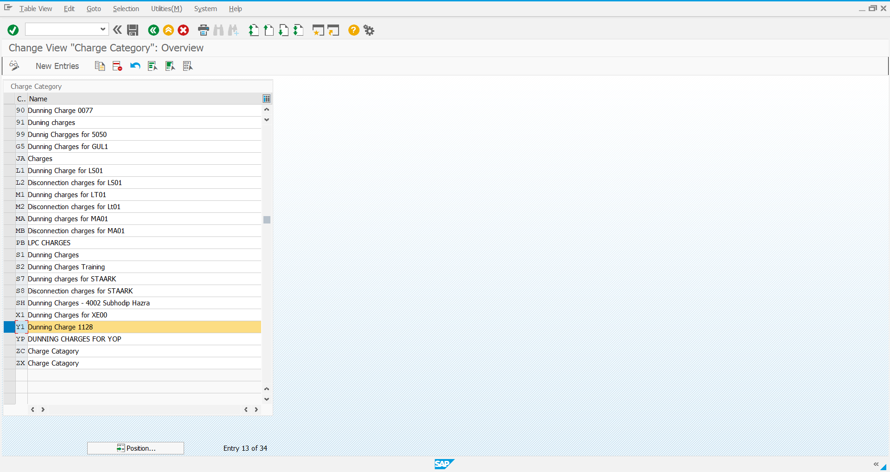

**Configuring Dunning Activities**

Step 1: Navigate using the following path

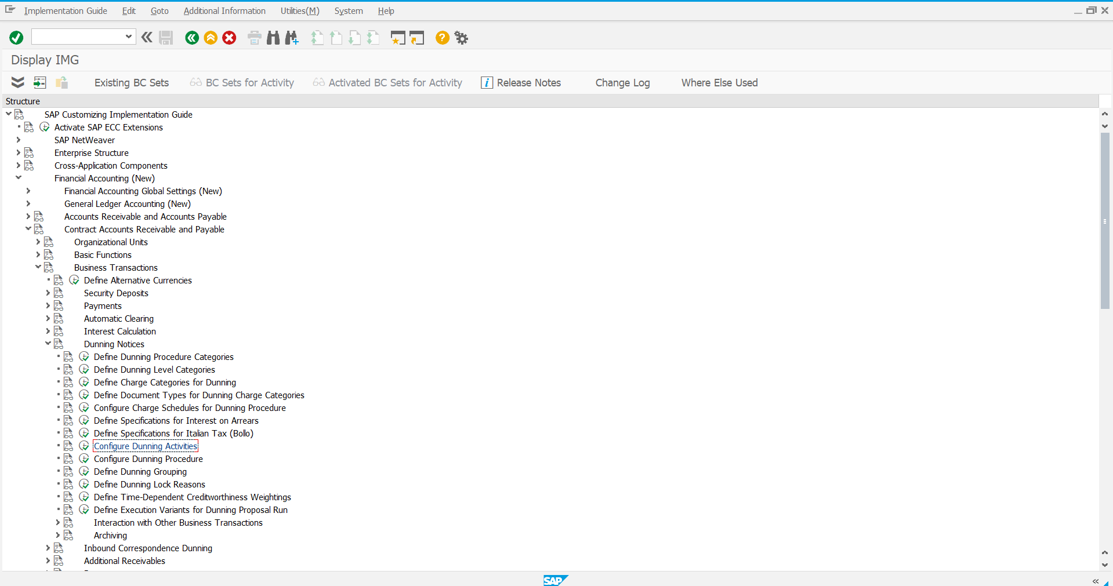

Step 2: Select New entries

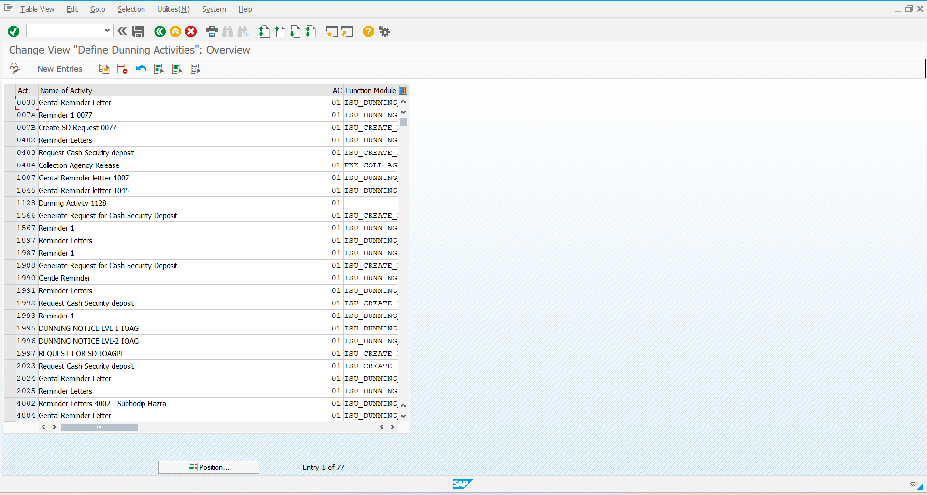

Step 3: Configure the new entries and save it

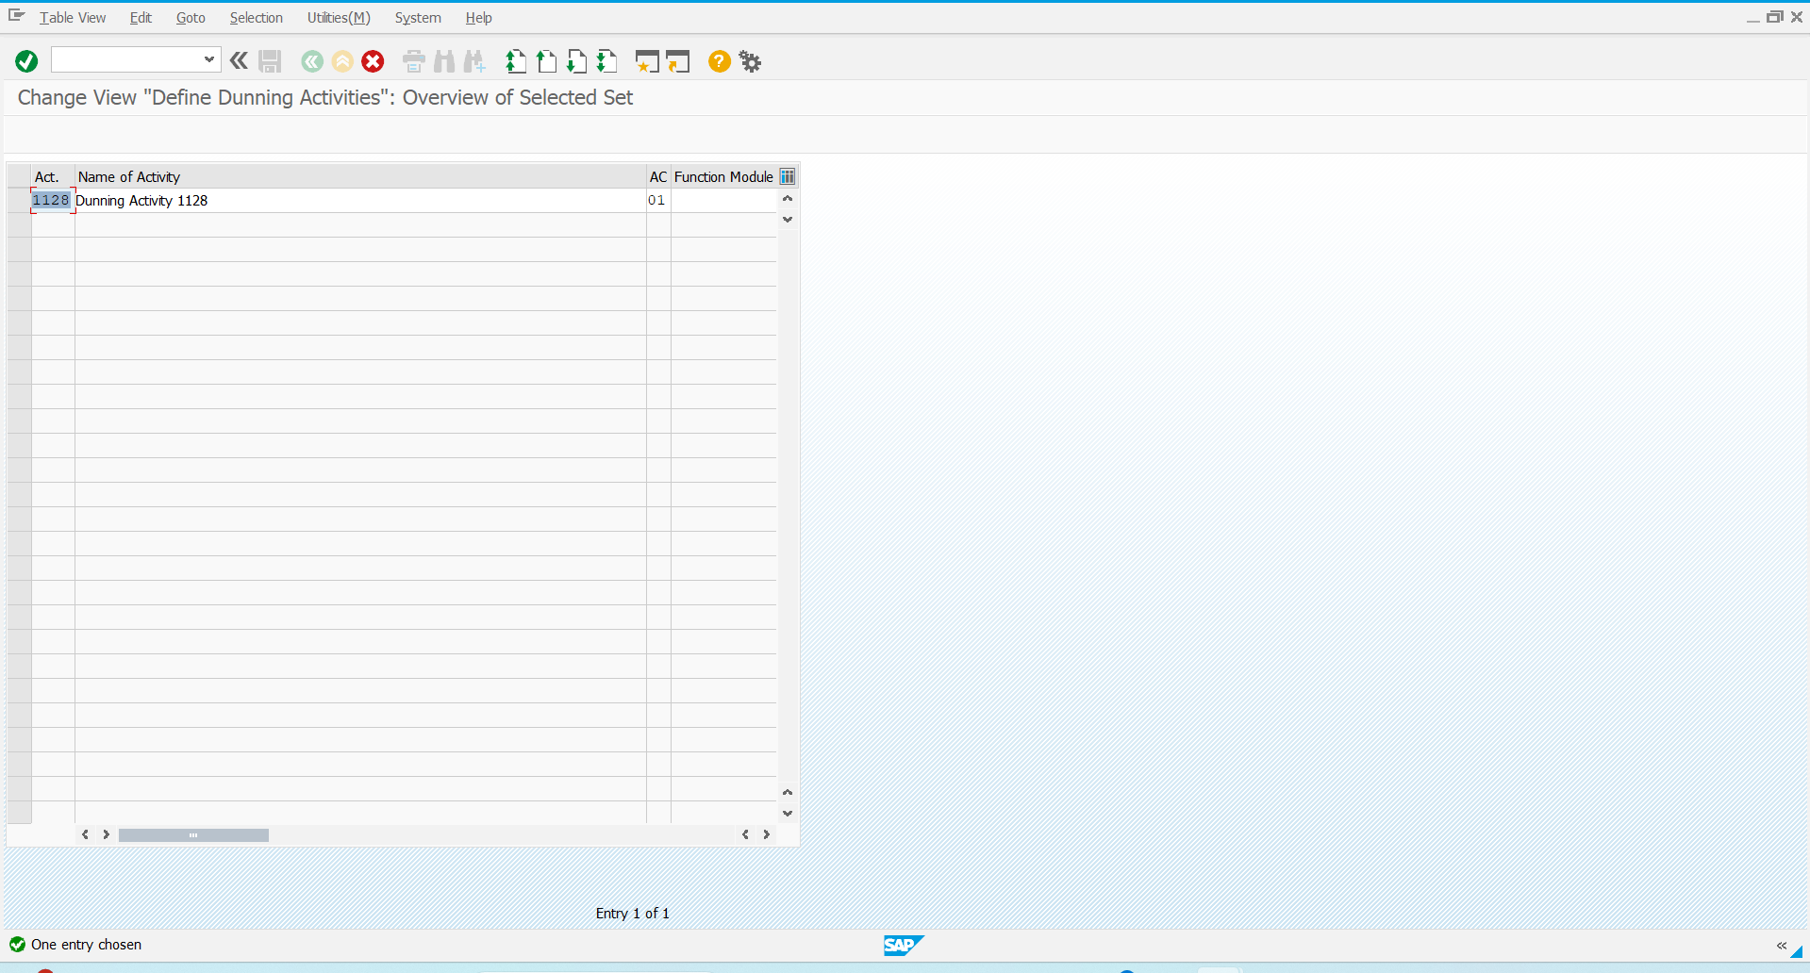

Step 4: New Dunning activity configuration is now available

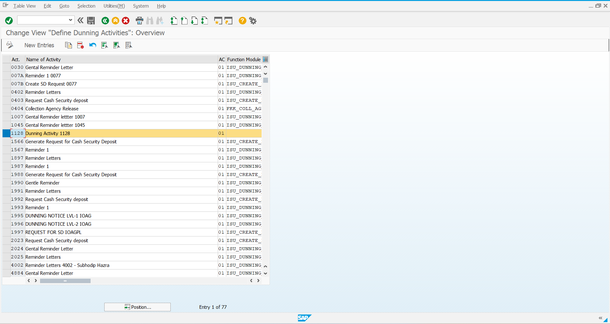

**Configure Dunning Procedure**

Step 1: Navigate using the below path

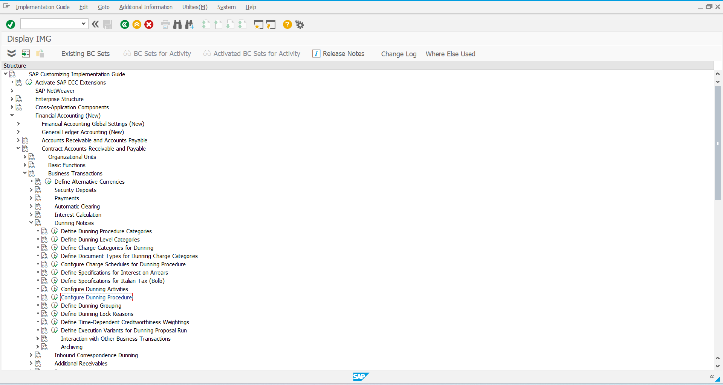

Step 2: Select New entries

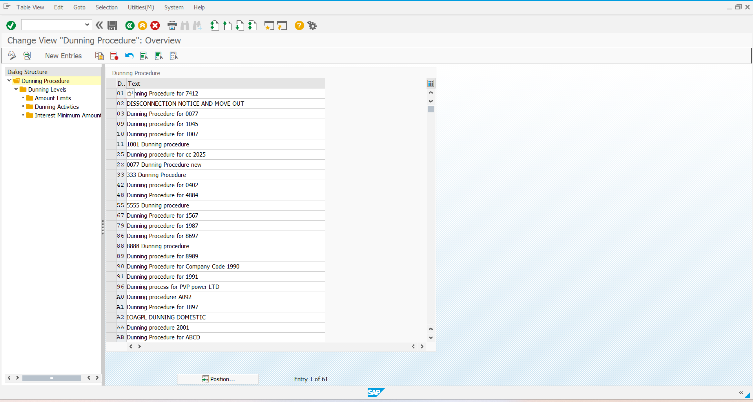

Step 3: Enter the required details

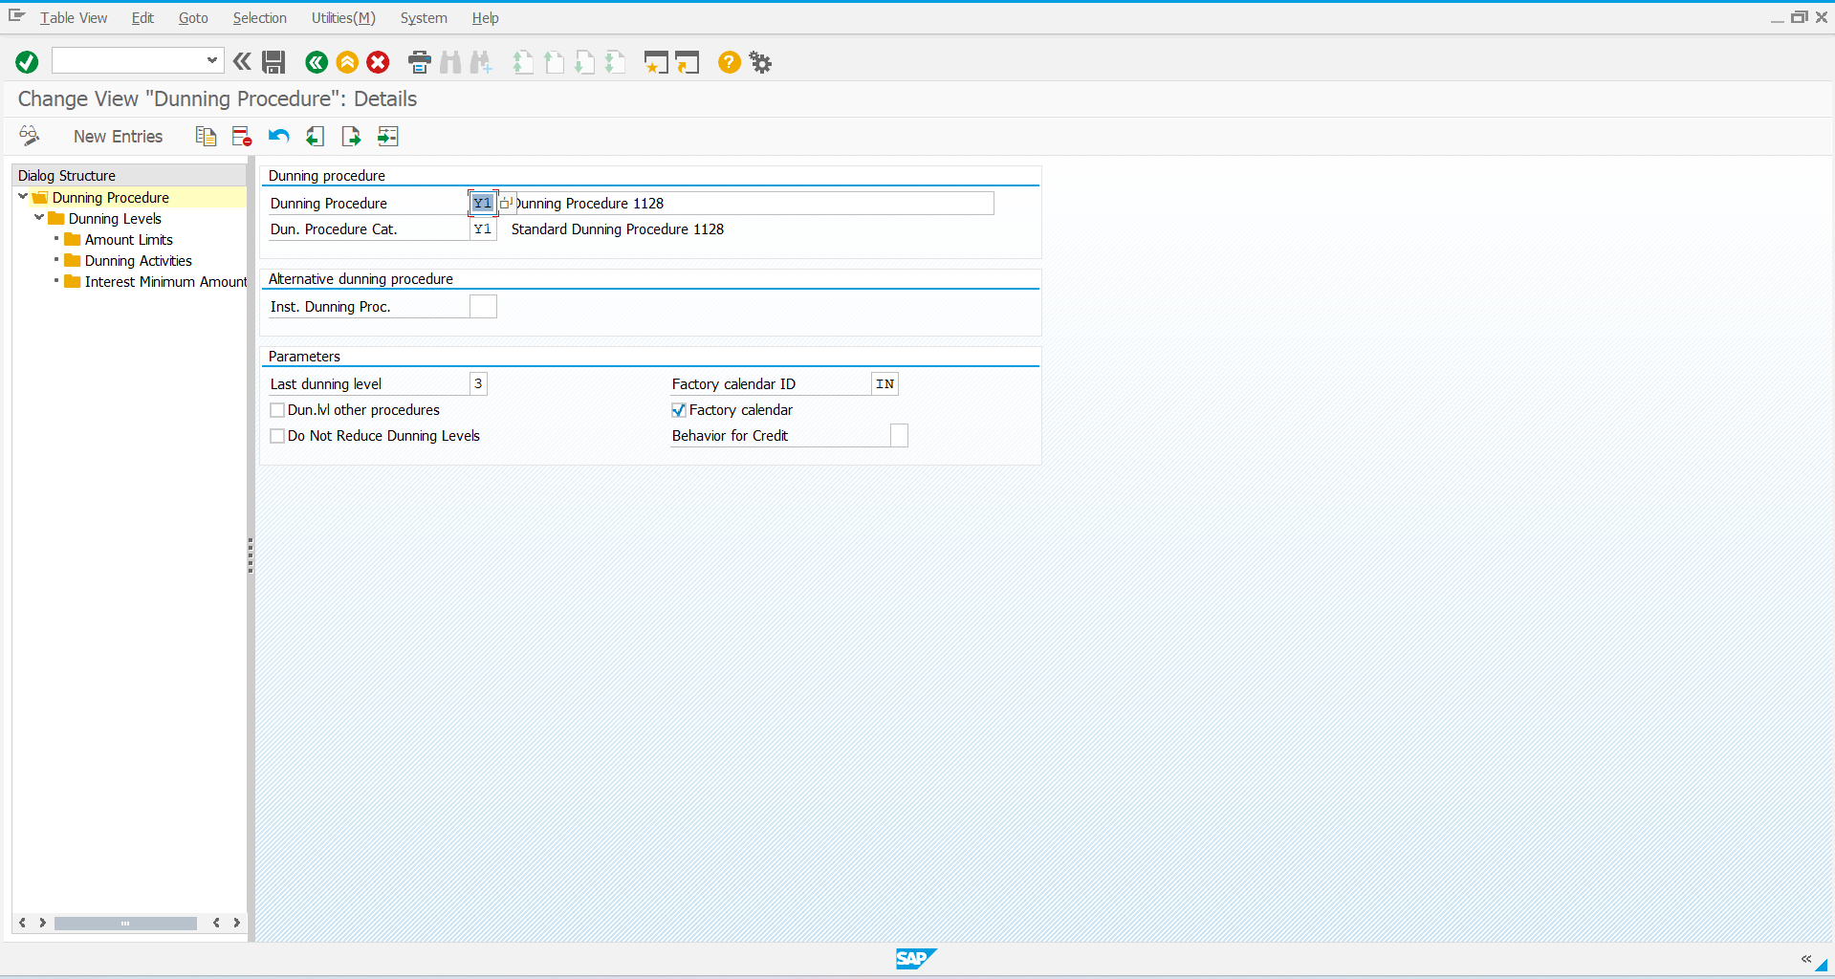

Step 4:

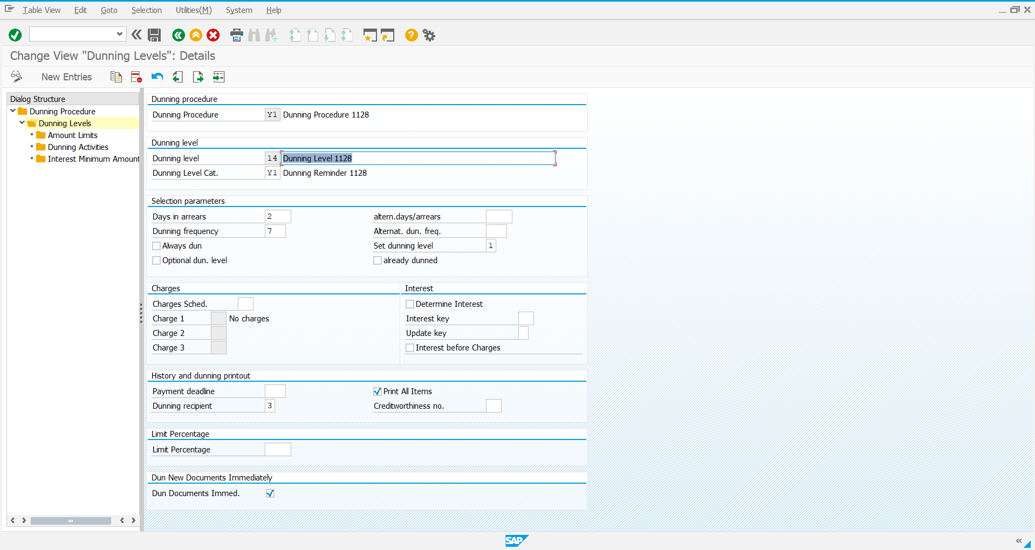

Step 5:

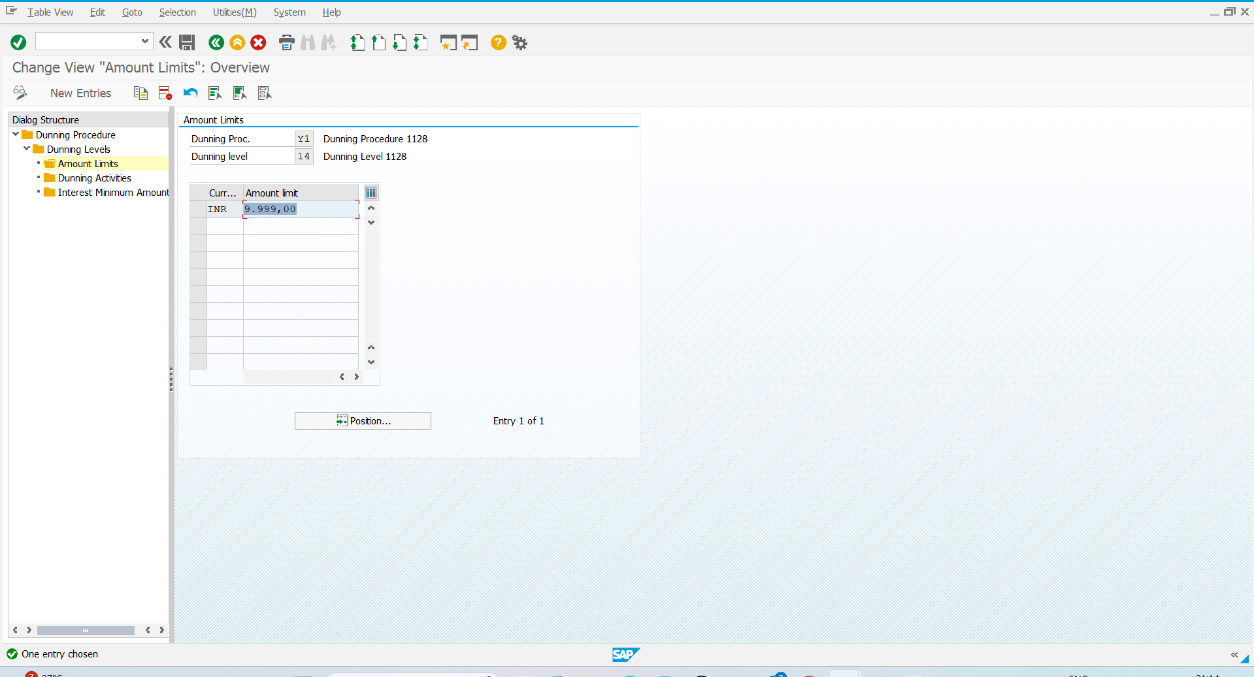

Step 6: and now save it

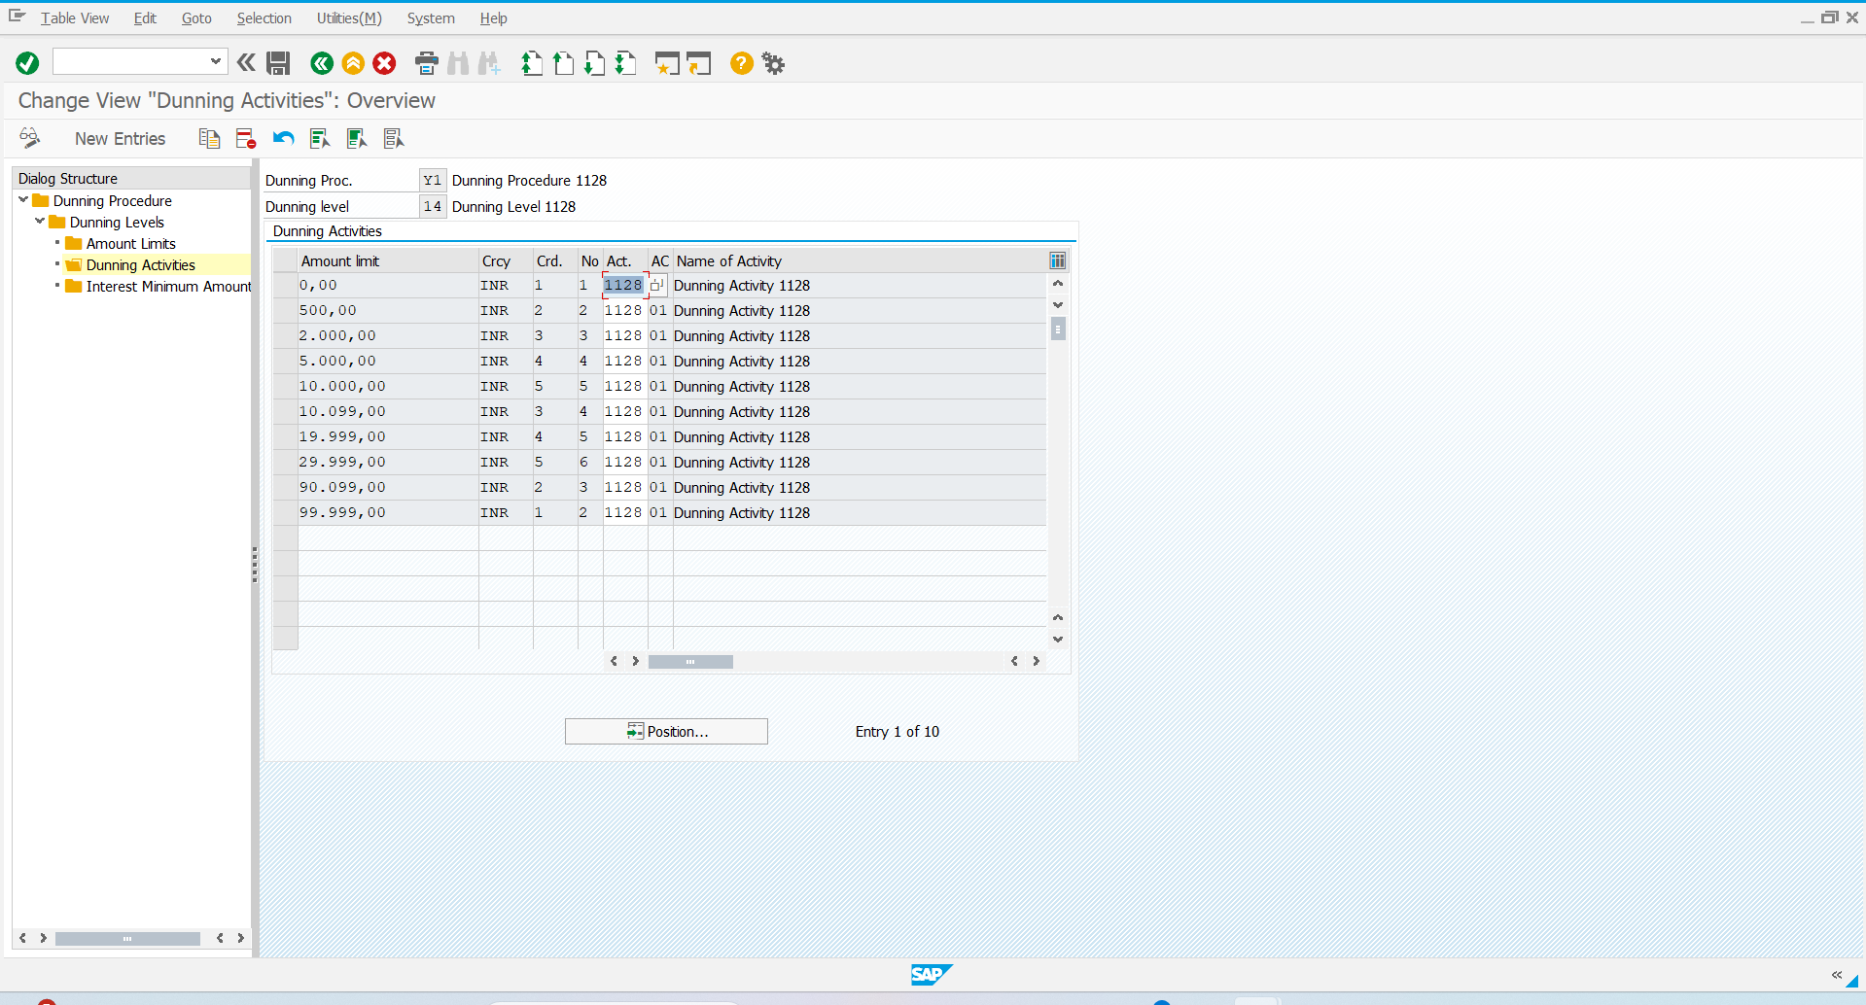

Step 7: Now we have a new Dunning procedure

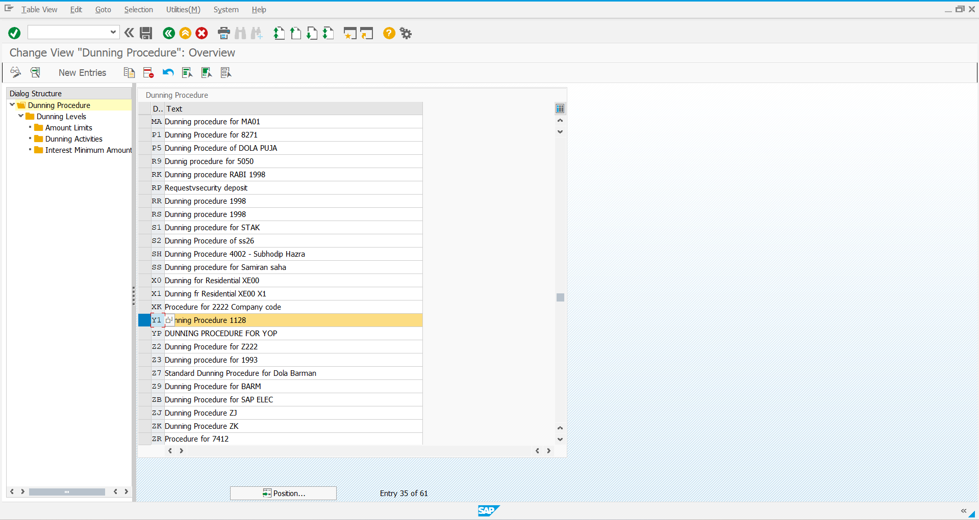

Step 8: Now assign the new dunning procedure to the Contract Account

